A

PROJECT ON

**“Airport Management & Organisation System”**

SUBMITTED TO

SAVITRIBAI PHULE PUNE UNIVERSITY

UNDER THE GUIDANCE OF

**PROF. Priyanka Jain**

SUBMITTED BY

**VISHWANATH SOPAN TAWARE (TYBBA-CA)**



**Department of Bachelors of Computer Applications**

**MAHARASHTRA EDUCATION SOCIETY’S GARWARE COLLEGE OF COMMERCE**

**KARVE ROAD, PUNE- 411004**

**2019 - 2020**



**Maharashtra Education Society’s GARWARE COLLEGE OF COMMERCE Karve Road, Deccan Gymkhana,**

**Pune41104**

**CERTIFICATE**

This is to certify that **MR. VISHWANATH SOPAN TAWARE** has successfully completed the Project entitled “Airport Management & Organisation System” and has submitted the same to the satisfaction during the academic year 2019 – 2020 towards partial fulfilment of the degree ‘Bachelor of Business Administration -Computer Application’ of Savitribai Phule University of Pune.

(PROJECT GUIDE) (BBA-CA IN CHARGE) (PRINCIPAL)

(INTERNAL EXAMINER) (EXTERNAL EXAMINER)

**INDEX**

|  |
| --- |
| 1. Introduction  * Introduction to system * Existing system * Proposed System * Objective of System * Scope of System |
| 2.Analysis   * Fact Finding Technique * Feasibility Study * Hardware & Software Requirement |
| 3.System Design   * + - E-R Diagram     - Context Level Diagram     - Data Flow Diagram     - Data Dictionary |
| 4.Form Design (with input values) |
| 5. Reports |
| 6. Limitations |
| 7. Future Enhancement |
| 8. Conclusion |
| 9. Bibliography |

**ACKNOWLEDGEMENT**

A successful project is the result of a good team-work which consists of not only the partners who put in their long and hard work but also those who guided them. Indeed, a true saying.

I would like to express my sincere and deep gratitude to my internal project guide **Mrs. Priyanka Jain** for her valuable guidance and suggestions.

I am also thankful to all the faculty members who supported me throughout the completion of my Project.

Last but not least, we express our gratitude to the almighty, without whose blessing nothing is possible.

**SYNOPSIS**

|  |  |
| --- | --- |
| 1. Tours Project Title : | A.O.M.S (Airport Organisation & Management System) |
| 1. Name of Group Member | Vishwanath Sopan Taware |
| 1. Technology | Front End: VB 6.0  BackEnd: Ms Access |
| 1. Objective/Aim | * Making a system wherein the airport management system is handled much easily * Reducing the amount of usage on the day to day functioning of the airport. * Proper flow of data in the system is maintained and no data redundancy is observed in the ERP System. * By means of this **airport management software**, users are able to control the company activities, connecting the application to other systems on airports such as booking … and external solutions (airlines, air navigation, etc.).. * A.O.M.S covers these areas:  1. AODB (Airport Operational Database), 2. RMS (Resources Management System), 3. Billing (Billing) 4. Commercial |
| 1. Introduction | ***A.O.M.S*** *is the* ***ERP software for operations****, resources and* ***airport management*** *based on* ***Visual Basic****. This solution includes a set of integrated modules into a unique* ***ERP software****.* |
| 1. Scope | * A.O.M.S is an integrated software developed of airport operating companies / government. The main aim of this project is to help the airport operating companies / government to manage their customers, flight operating companies and customer. It makes all operations of the airport easy and accurate. * The stand-alone platform makes airport management easy by handling requests and providing services for the customers. Different modules have been incorporated in this proct to handle different parts and sectors of the airport management field. |
| 1. Modules | 1. Customer Portal 2. Ticket Booking Portal 3. Boarding Pass Counter Portal 4. Airport Operations Portal 5. ATC Portal 6. Ground Operations |

**ABSTRACT**

The Airport management system is a stand-alone based application and maintains a centralized repository of all related information. The objective of this project is to develop a system that automates the processes and activities of a airport and customer details. The purpose is to design a system using which one can perform all operations related to travelling in airplanes and functioning of airport.

**INTRODUCTION TO SYSTEM**

* Admin enter his user id and password for login to enter master module screen.
* Admin can maintain his data sources.
* Admin can manage the fleet of airplanes.
* Administrator will enter the data for the related employee.
* Administrator giving information to generate various kinds of MIS reports.

**EXISTING SYSTEM**

* A Customer has to approach various application to ask inquiry for travelling then book ticket.
* Finally pay payment and collect receipt.
* Difficult to maintain the customer details of travel and payment receipt in register.
* They register travelling information manually.
* Use travelling facility for the limited area or person.
* All work is done manually.

**PROPOSED SYSTEM**

* To create stand-alone application for our organization.
* To provide add/remove airplane facility for Admin.
* To generate different types of report.
* To provide the ticket booking facility for Customer.
* To provide boarding pass details.
* One-month advance booking will be getting 10% off.
* Customer can cancel the booking then return 15% deducted from the amount.
* Services provided by system
  + Search flight
  + Booking
  + Cancel Booking

**OBJECTIVE**

* Main objective of this system is to provide customer registration. Give information of flight rates, ticket booking system and searching facility and also generate different types of report.
* Continuously provide enjoyable quality travel on time and on budget.
* Provide a high standard of service suitable for individuals. Seeking relaxing, Comfortable and Memorable experiences in the hospitality and travelling with the help of airport management system.

**SCOPE**

* Airport management system is an integrated software developed of airplane operating companies. The main aim of this project is to help the airplane companies to manage their customers, flight and employee. It makes all operations of the flight operating company easy and accurate.
* The stand-alone platform makes airport management easy by handling customer requests and providing services for the customers. Different modules have been incorporated in this project to handle different parts and sectors of the airport management field.

ANALYSIS

**Fact Finding Technique:**

In order to find facts about the system, we first searched online to gather up as much detail as we could on existing systems.

**Feasibility Study:**

An important outcome of preliminary investigation in the determination that the system requested is feasible or not.

**Operational Feasibility:**

The system will be developed according to the airport needs and will have all the specification demanded by the company. The user will already be familiar with the facility provided by any web site.

**Technical Feasibility Study:**

The software is developed Intel processor which is commonly available in the market that can be used to implement the system. The hardware and software requirement are minimal and no specification or special training is required as the user is already familiar with the system. The memory requirements of the system are in kilobytes and the system can be kept on CD. The size of the database can be depending on the use of the user.

**Economic Feasibility**:

Since the system is window based and developed on Visual Basic. The system configuration is also minimal. Thus the investment required is very less.

**HARDWARE AND SOFTWARE REQUIREMENT**

* **Minimum Hardware Requirements:-**

1. Processor – Pentium 4 1ghz
2. Memory- 512mb RAM Or More
3. HDD- 10 GB Or More
4. Additional Devices- CDROM/USB Drive And Printer

* **Minimum Software Requirements:-**

1. OS- Windows XP/07
2. Front End- Microsoft Visual Basic 6.0
3. Back End- Microsoft Access

**SYSTEM DESIGEN**

**ENTITY RELATIONSHIP DIAGRAM**

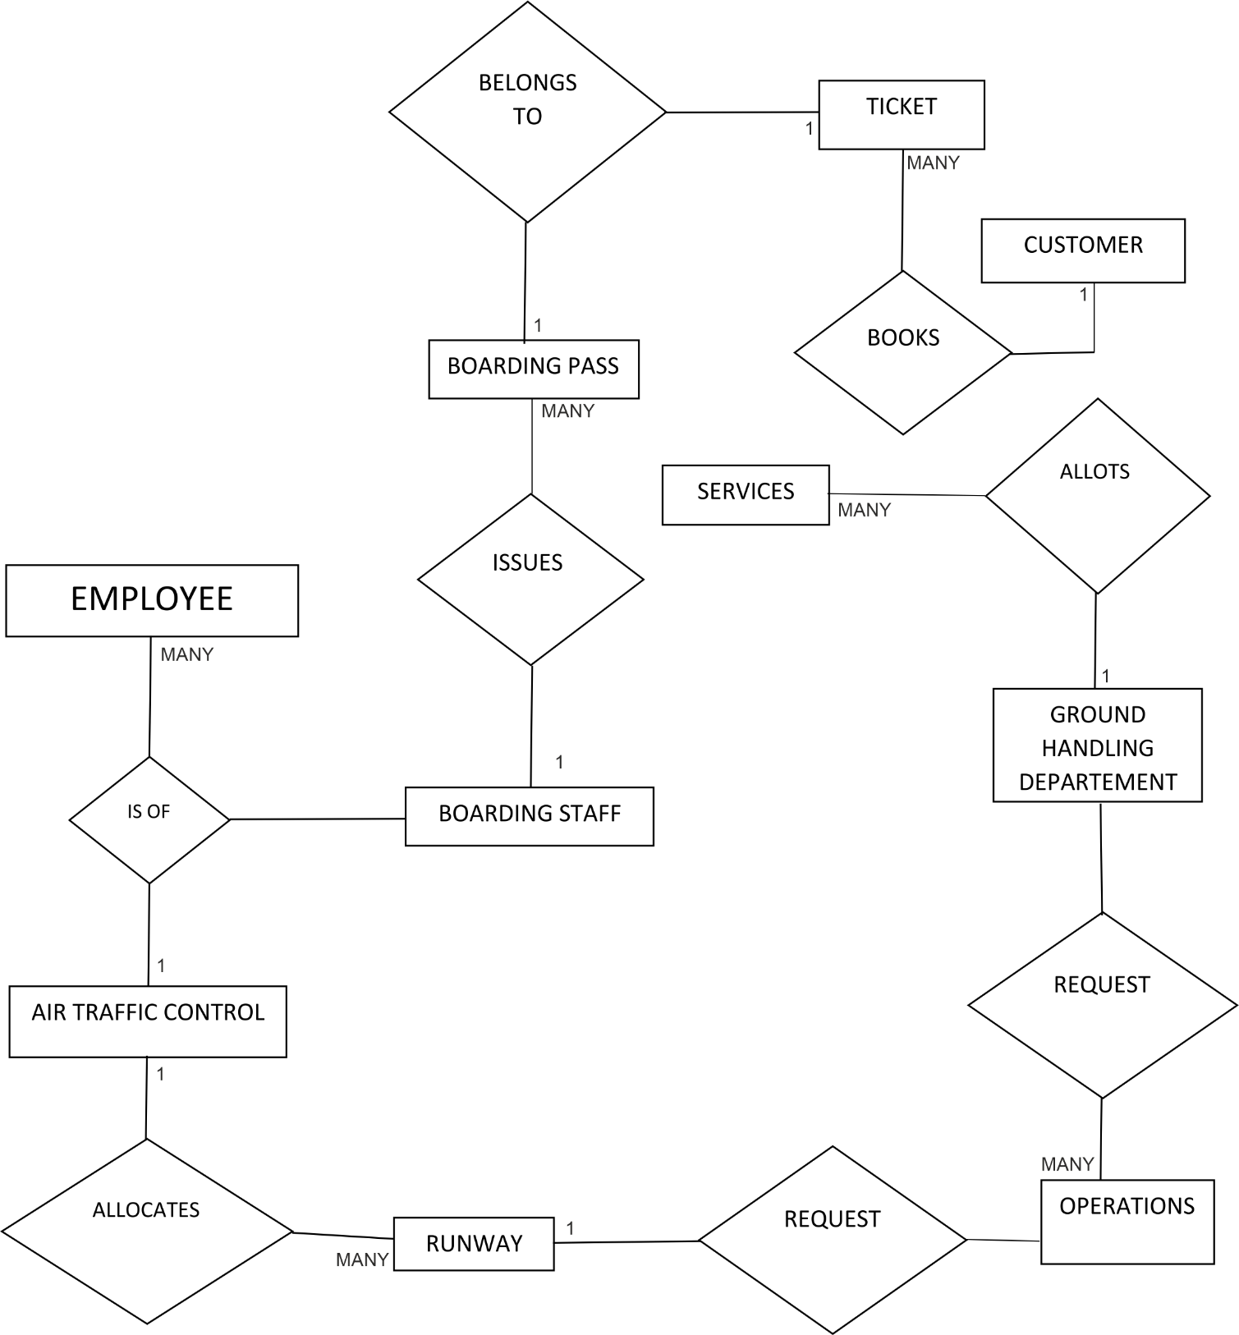

**CONTEXT LEVEL DIAGRAM**

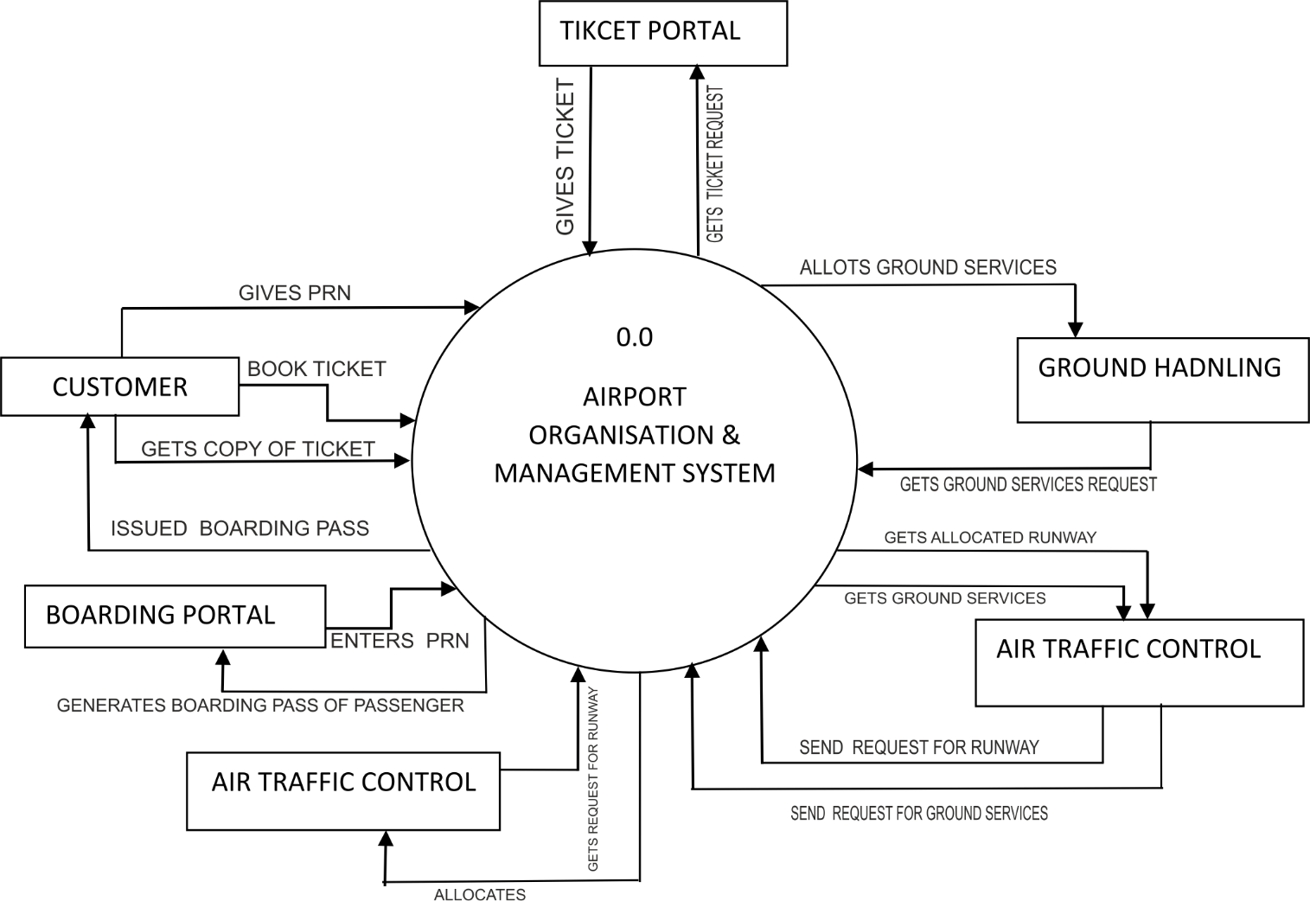

**FIRST LEVEL DFD**

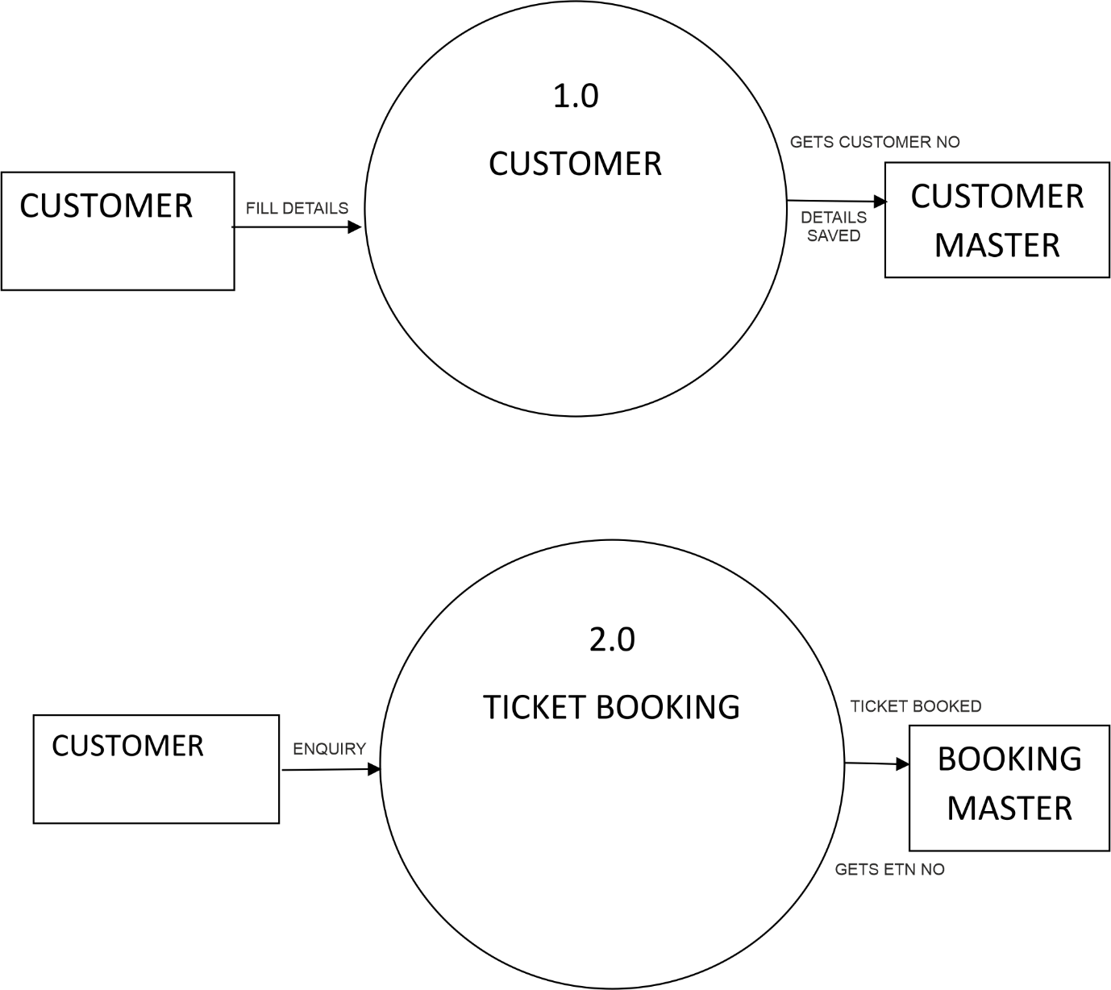

**FDD DIAGRAM**

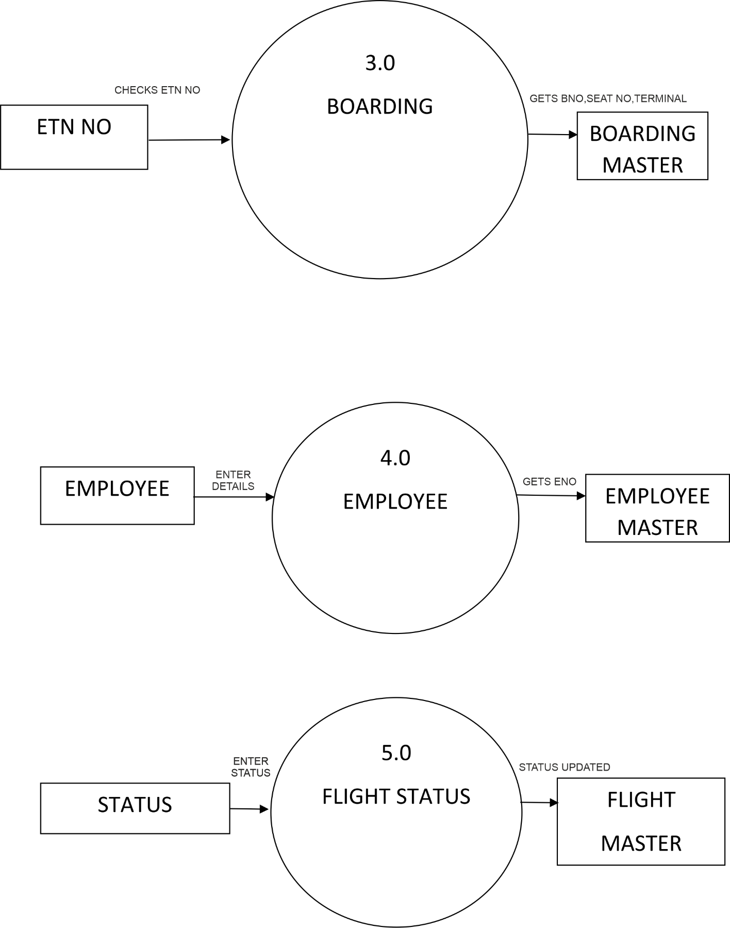

**DATA DICTIONARY**

**1)Admin**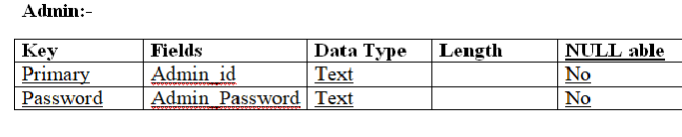

**2)Customer**

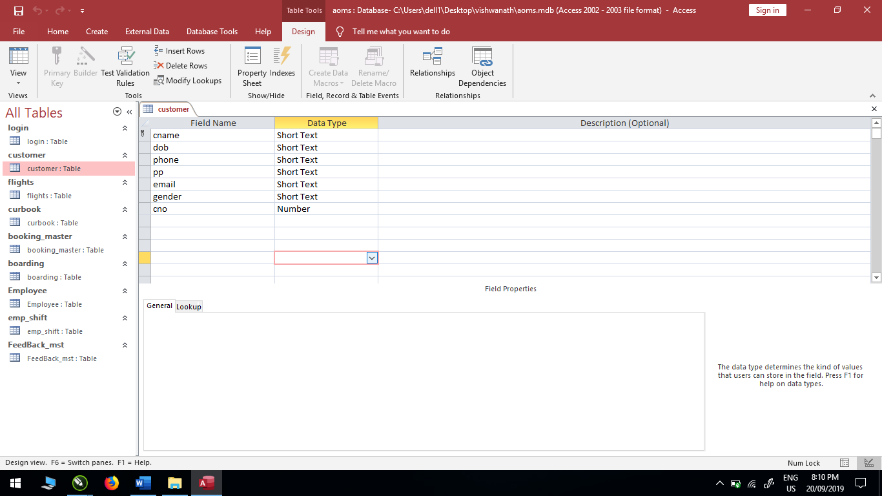

**3)Flights**

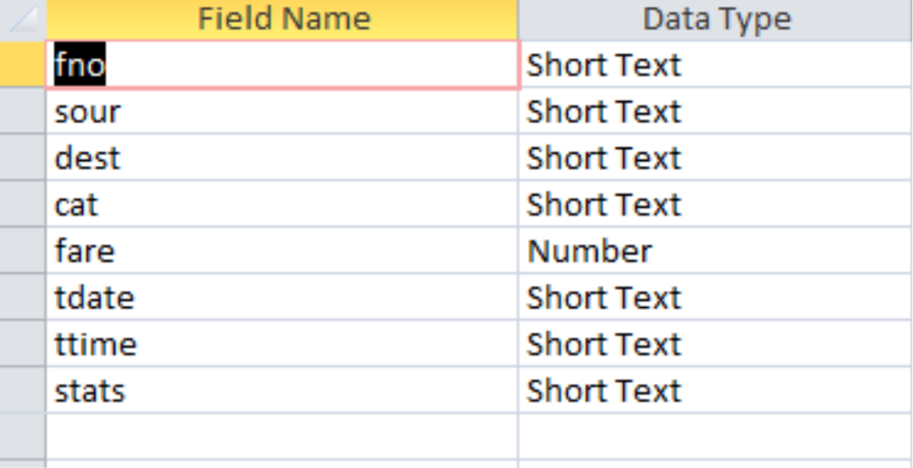

**4)Customer Booking**

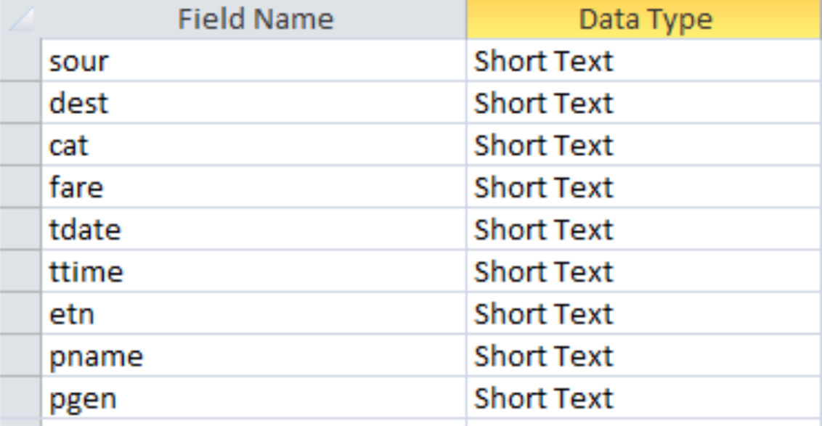

**5)Boarding**

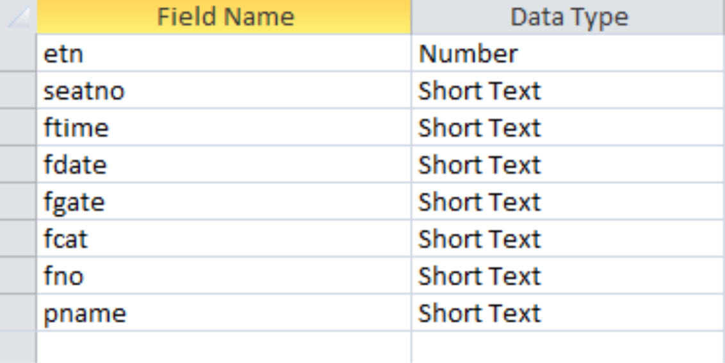

**FORM DESIGN**

**1)Login Form**

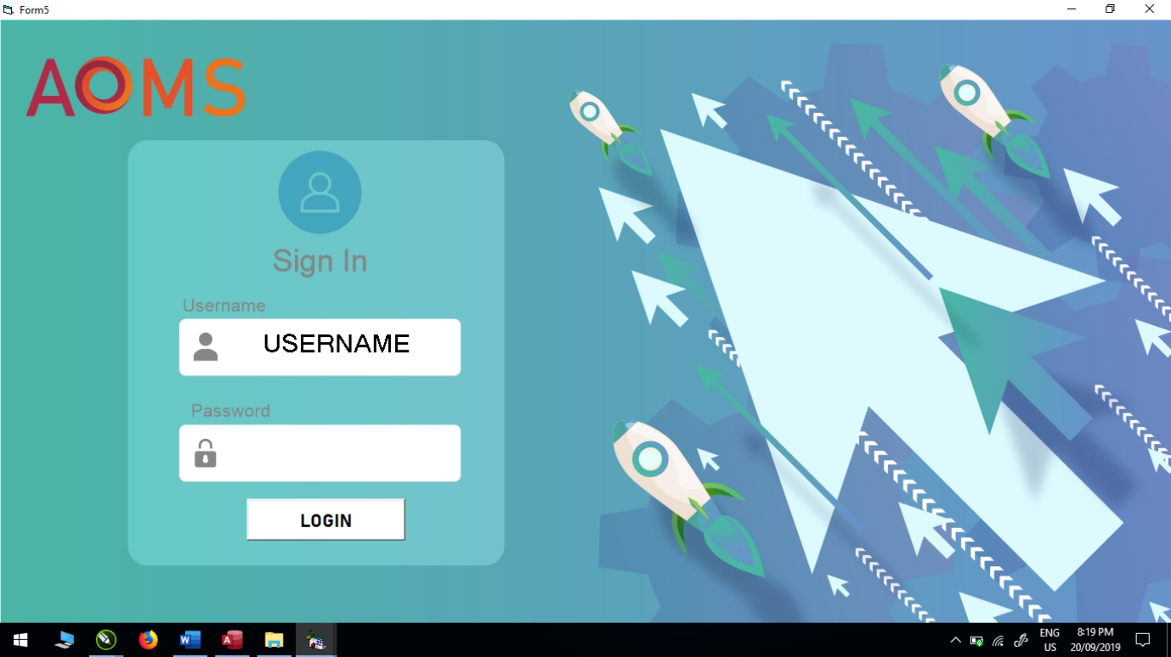

**2) Loading Window**

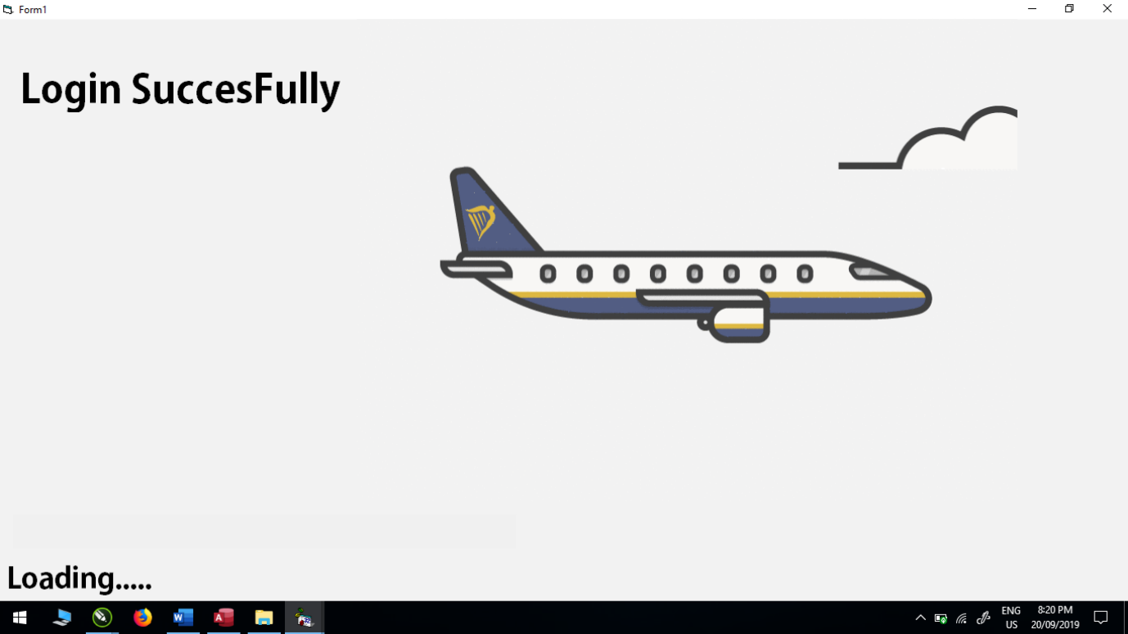

**3)MDI Form**

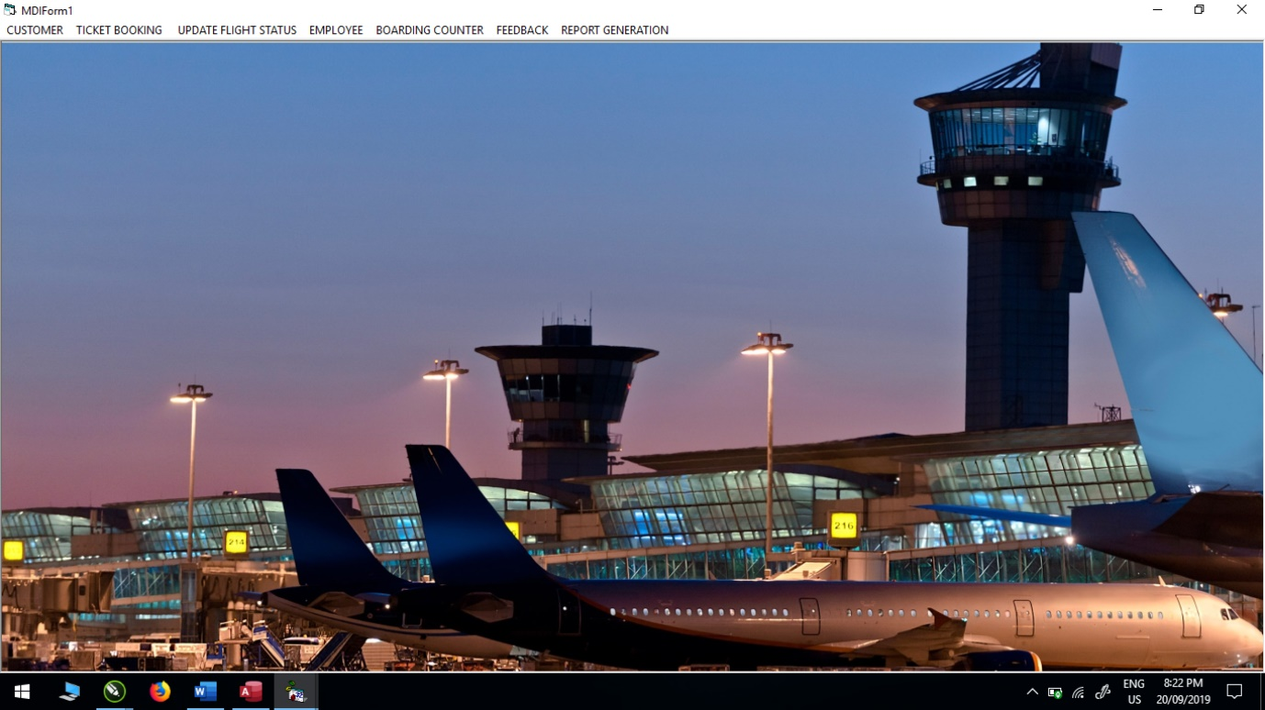

**4)Customer Form**

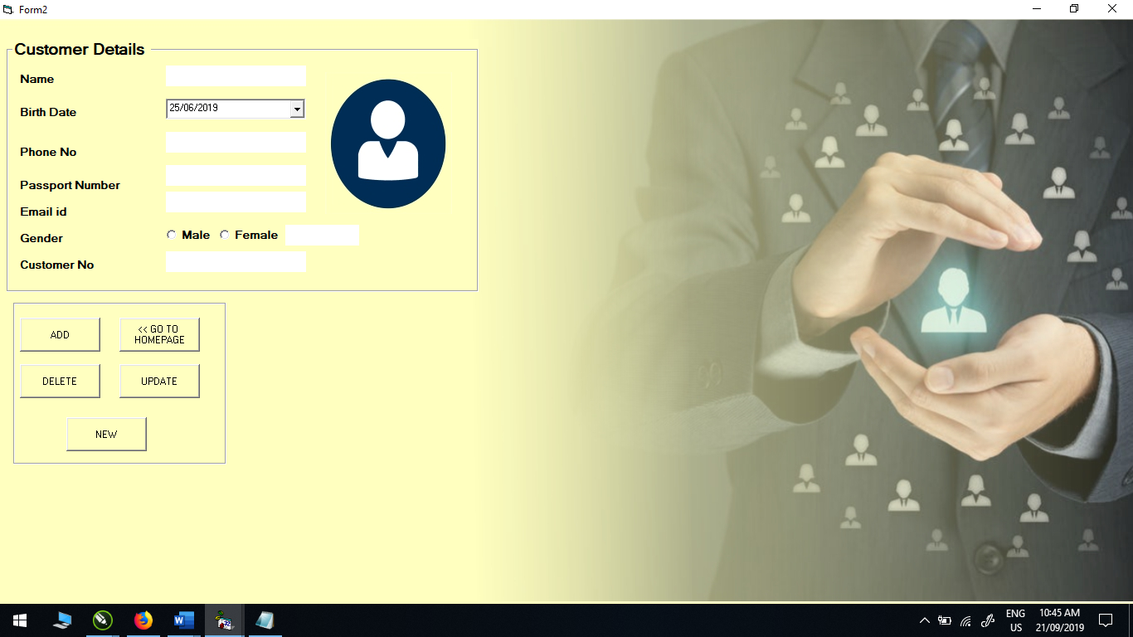

**5)Ticket Booking**

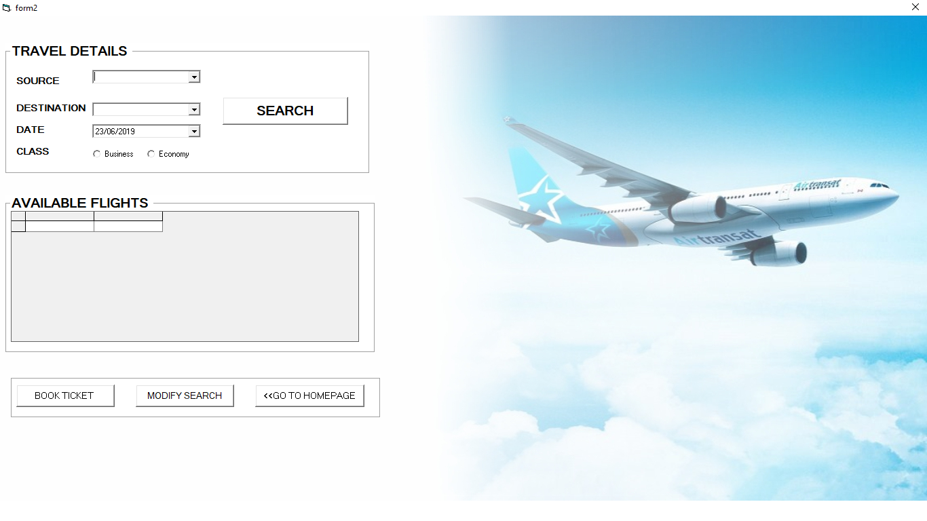

**6)Employee Details**

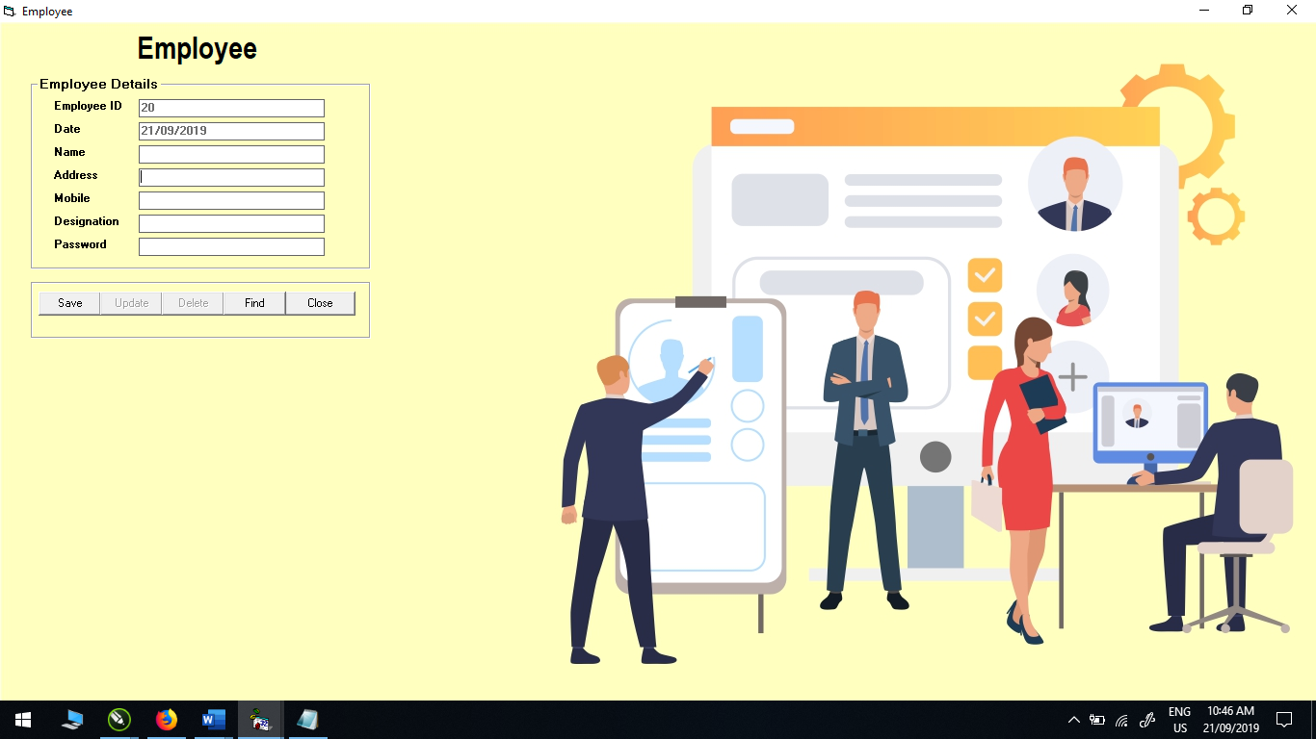

**REPORTS**

**1)Customer Report**

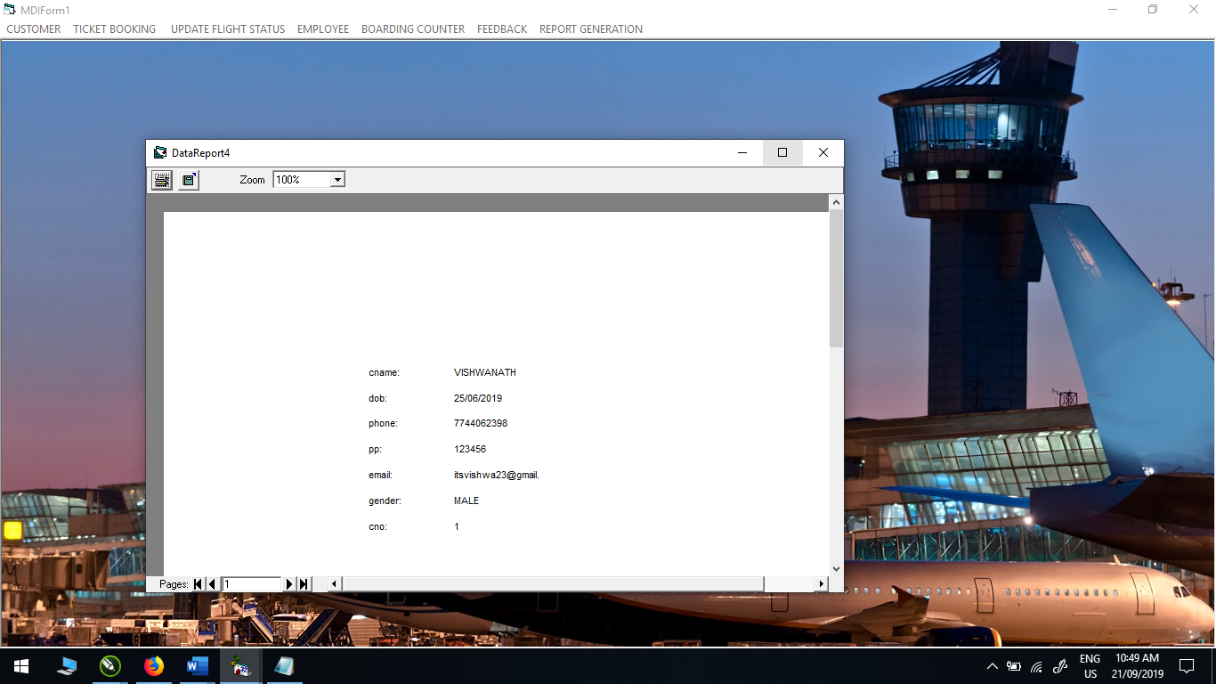

**2)Employee Report**

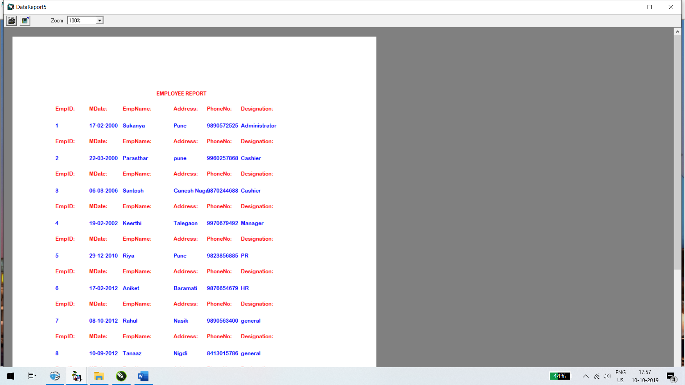

**LIMITATIONS**

List of Limitations Which Is Available In Airport Management System -

* Data repetition
* Slow speed
* Ambiguous
* No proper format
* Less storage
* Project is limited to stand alone environment

**FUTURE ENHANCEMENT**

* Any agency can make use of it for saving customer details in database.
* This application can easily implemented under various situation.
* We can add new features as and when we require.
* Reusability of this application is also possible.

**CONCLUSION**

After making this software we end up at a conclusion that this way of managing renting details of different modules is much easier...

Data access became simple. Speed increased, decrease in manpower, storage volume increased and more user-friendly…

No possibilities of data loss there…

**BIBLIOGRAPHY**

* **BOOKS:**

|  |
| --- |
| 1] Visual Basic 6.0 – Tech Max |
| 2] Visual Basic 6.0 – Thakur |
| 3] Visual Basic 6.0 – Black Book |
| 4] Software Engineering – Pressman |
| 5] Software Engineering – PankajJalote |

C:\Program Files\Microsoft Office\MEDIA\CAGCAT10\j0299125.wmf

* **ONLINE REFERENCE:**

C:\Program Files\Microsoft Office\MEDIA\CAGCAT10\j0195384.wmf

|  |
| --- |
| 1] [www.w3schools.com](http://www.w3schools.com) |
| 2] [www.theserverside.com](http://www.theserverside.com) |
| 3] [www.visual.com](http://www.visual.com) |
| 4] [www.inettutor.com](http://www.inettutor.com) |